**Group 5**

**Dublin City Management’s Behavioral Model:**

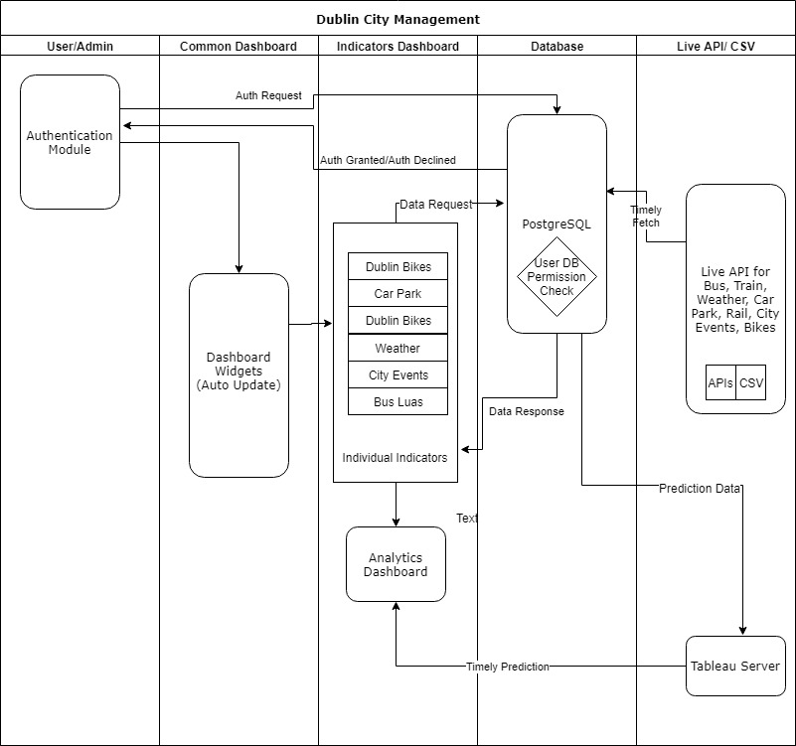

Sequence Diagram of Dublin City Management

The architecture supports 2 types of actors namely- City admin and general user. General user have restricted access to the application, whereas admin has all the access. This behavioural scenario has been explained below for both actors.

1. PostgreSQL database timely fetches data for all indicators from various APIs and CSV file. The database also stores information about users
2. Whenever any user logs in to the application, the request is handled by Authentication module. It is responsible to decide whether to grant or decline access to other dashboards.
3. Whenever, log in request is received by the authentication module, it sends it to the database to check, whether a user is an admin or not. If the user is a general user then the request is declined and access is not granted. However, if the admin logs in the portal and if its credential matches the data in the database, access is granted.
4. General user have access to home page and can view widgets.
5. After log in city user can view all the individual dashboard.
6. When the request for dashboard is raised the data request for the corresponding dashboard data is sent to the PostgreSQL database.
7. This request is validated and data response is sent to the dashboard.
8. The flow for analytical dashboard is different from rest of the dashboards.
9. When the request for analytical dashboard is raised, it is fulfilled by tableau server.
10. Tableau server gets the prediction data for analysis from PostgreSQL database. The data is manipulated and modelled in Tableau and the response is sent to the analytics dashboard. Thus, completing the flow.